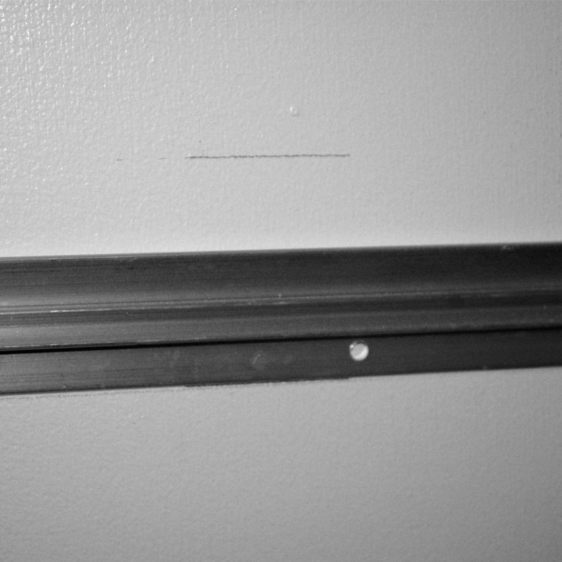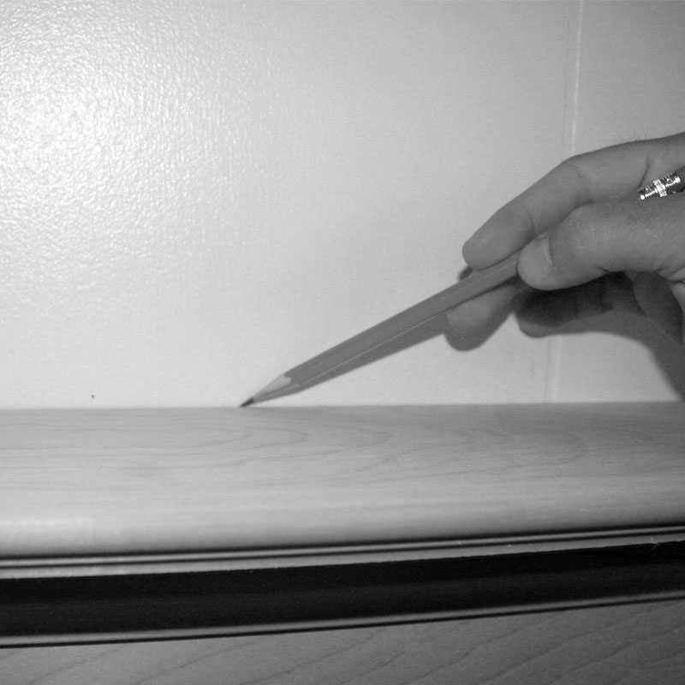**Prestige French Cleat Hanging System**

**Step 3, Now that your legs are attached securely to the header you can install the mantel surround. On the back of each leg about 6” from the bottom you will need to add some construction adhesive be careful and not add too much so it will not squeeze out onto the wall surface. Now hang your mantel from the bracket and be sure to push in at the bottom so the adhesive will secure the legs to the wall. If you have any questions about installation please call customer service at 800 820 7177.**

**Step 1, After the legs are installed into the header by using the cam locks, you also need to install the scab blocks, 6” x 6”, to the back of the header and legs with the 1 ¼” screws provided. Then with 2 people stand the mantel up on the wall and make a mark on the wall in the center of the mantel and on both ends of the mantel.**

**Step 2, Below the 3 marks that are on the wall measure down 2 3/8” and make another mark on the wall. This is where you position the bottom of the cleat. Make sure that when you attach the cleat to the wall that you screw into the studs. This installation will only work if your wall is perfectly straight, if not back out the screws until you are able to hang the mantel on the cleat.**

**Prestige French Cleat Hanging System**

**Step 2, Below the 3 marks that are on the wall measure down 2 3/8” and make another mark on the wall. This is where you position the bottom of the cleat. Make sure that when you attach the cleat to the wall that you screw into the studs.**

**Step 3,**